**Documentation of our website**

|  |  |
| --- | --- |
| Group member name | Roll number |
| Rubesha Memon | 21sw072 |
| Anjli kumari | 21sw118 |
| Yogeeta Lohana | 21sw041 |
| Rizeen Yasin | 21sw147 |

**SwiftSneaks**

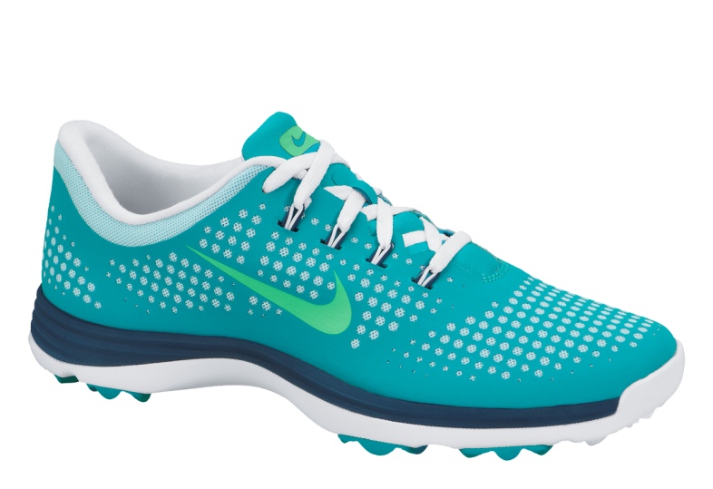

SwiftSneaks is a shoe brand that sells sneakers, flats, boat shoes and boots.

The website offers a separate page for each kind of shoe we offer.

Lets talk about the pages we’ve made one by one.

1. Landing Page

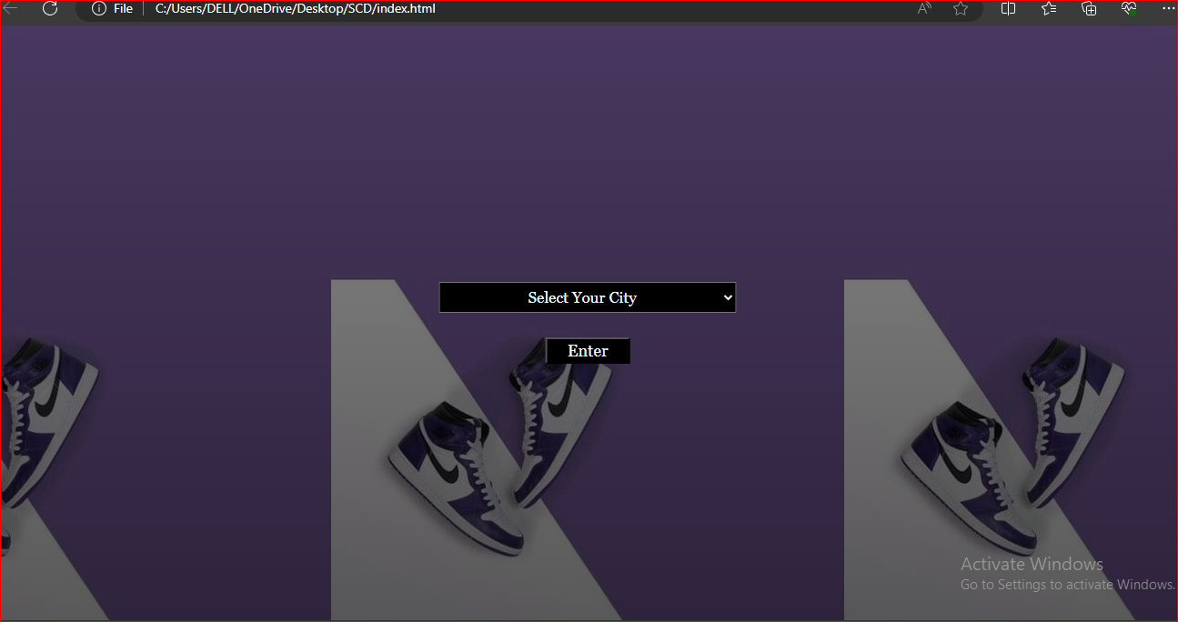

## Approach we have used:

**HTML Document Components:**

1. `<!DOCTYPE html>`: Declaration specifying the HTML version.

2. `<html lang="en">`: Root element defining the document type and language.

3. `<head>`: Container for metadata such as character set, viewport settings, and title.

- `<meta charset="UTF-8">`: Character encoding declaration.

- `<meta name="viewport" content="width=device-width, initial-scale=1.0">`: Viewport settings for responsive design.

- `<title>Landing</title>`: Title of the HTML document.

- `<link rel="stylesheet" href="index.css">`: Link to an external CSS stylesheet.

4. `<body>`: Main content area of the HTML document.

- `<div class="available">`: Division containing the city selection dropdown and button.

- `<select name="city" id="" style="background-color: black; color: aliceblue; width: 50vh;">`: Dropdown menu for selecting a city with inline styling.

- `<Option> Select Your City</Option>`: Default option in the dropdown menu.

- `<Option>Abbottabad</Option>`: City option in the dropdown menu.

- `<Option>Hyderabad</Option>`: City option in the dropdown menu.

- `<Option>Islamabad</Option>`: City option in the dropdown menu.

- `<Option>Karachi</Option>`: City option in the dropdown menu.

- `<Option>Lahore</Option>`: City option in the dropdown menu.

- `<br>`: Line break.

- `<button onclick="document.location='home.html'"> Enter</button>`: Button triggering redirection to "home.html" page on click.

5. `</body>`: End of the document's body.

6. `</html>`: End of the HTML document.

**CSS Styles:**

1. `*`: Styling applied to all elements.

2. `body`: Styling for the body element.

3. `.available`: Styling for elements with the class "available".

4. `.available select`: Styling for the select element within elements with the class "available".

5. `button`: Styling for button elements.

6. `button:hover`: Styling for button elements when hovered over.

7. `@media only screen and (max-width: 600px)`: Media query for screens with a maximum width of 600 pixels, adjusting the width of the select element.

1. Home Page

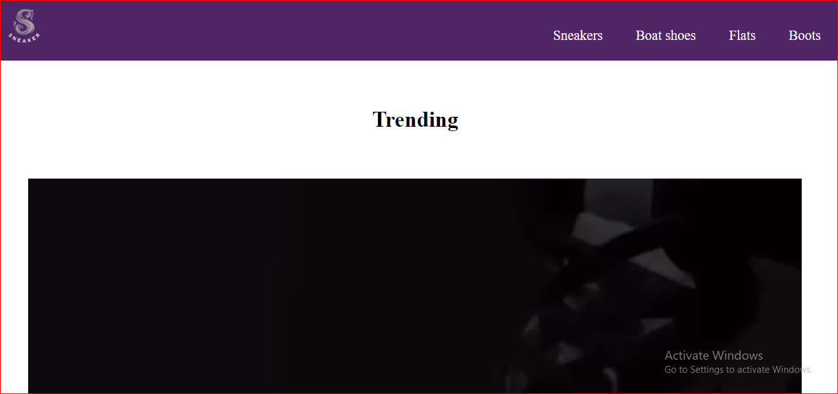

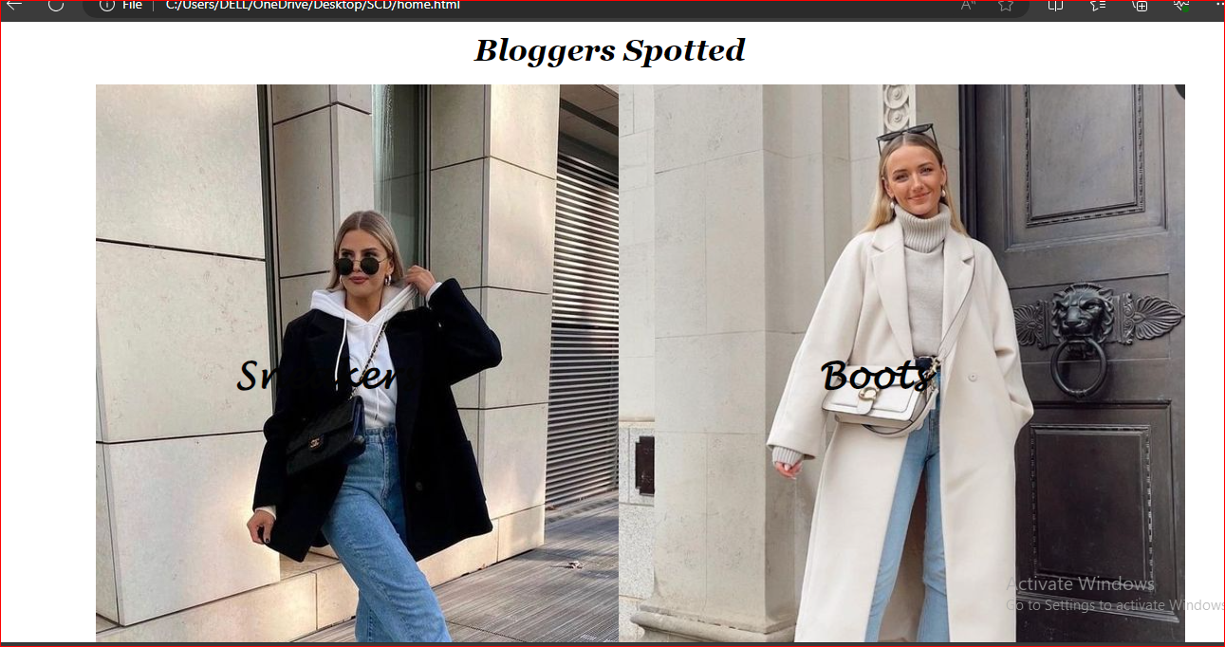

**HTML Document Components:**

- `<link rel="stylesheet" href="style.css">`: Link to an external CSS stylesheet.

- `<title>SNEAKERS</title>`: Title of the HTML document.

- Internal `<style>` block for inline CSS styling.

. `<body>`: Main content area of the HTML document.

- `<div class="image">`: Division containing the brand logo image.

- `<img src="logo/main logo.png" alt="Image not found" class="logo">`: Brand logo image.

- `<nav class="menu">`: Navigation menu containing links to different product categories.

- `<a href="Boots.html">Boots</a>`: Link to the boots category page.

- `<a href="flat.html">Flats</a>`: Link to the flats category page.

- `<a href="boatshoe.html">Boat shoes</a>`: Link to the boat shoes category page.

- `<a href="sneaker.html">Sneakers</a>`: Link to the sneakers category page.

- `<center>`: Center-aligned content container.

- `<h1>`: Heading indicating "Trending".

- `<video src="logo/Trending.mp4" autoplay style="object-fit: cover; height: 100vh; width: 90.5vw;"></video>`: Video element displaying trending content.

- `<h1>`: Heading indicating "Bloggers Spotted".

- `<img src="logo/blogger1.jpg" style="margin-left: 110px;">`: Image of the first spotted blogger.

- `<div class="centered"><h1><a href="sneaker.html">Sneakers</a></h1></div>`: Center-aligned heading with a link to the sneakers category page.

- `<img src="logo/blogger2.jpg" alt="" style="margin-left: -17px; height: 846px;">`: Image of the second spotted blogger.

- `<div class="right"><h1><a href="Boots.html">Boots</a></h1></div>`: Right-aligned heading with a link to the boots category page.

- `<div class="foot">`: Footer section.

- Footer content indicating copyright information.

1. Sneakers page

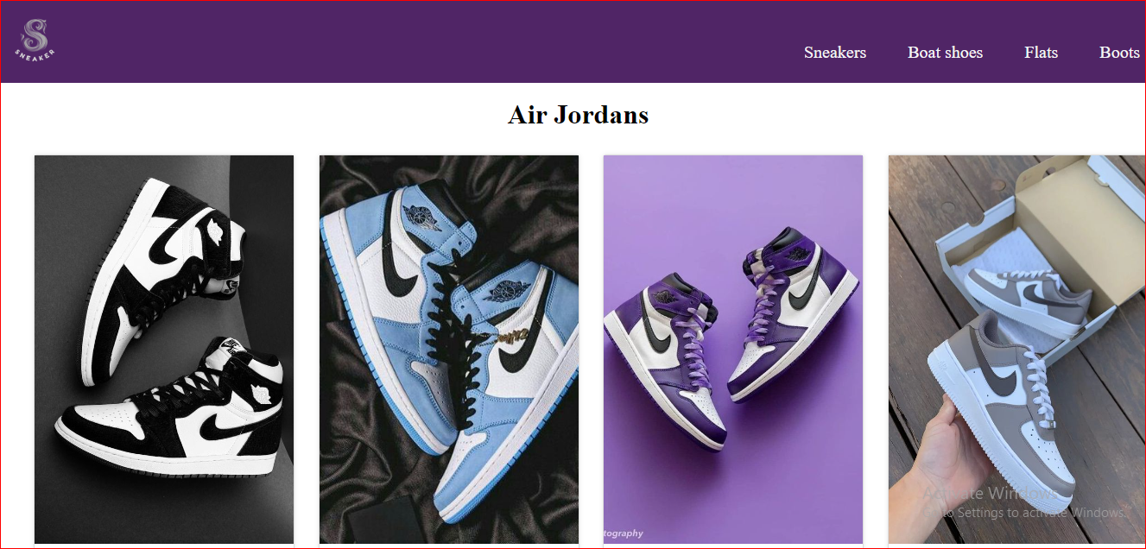

<body>: Main content area of the HTML document.

<div class="image">: Division containing the brand logo image.

<img src="logo/main logo.png" alt="" class="logo">: Brand logo image.

<nav class="menu">: Navigation menu containing links to different product categories.

<a href="Boots.html">Boots</a>: Link to the boots category page.

<a href="flat.html">Flats</a>: Link to the flats category page.

<a href="boatshoe.html">Boat shoes</a>: Link to the boat shoes category page.

<a href="sneaker.html">Sneakers</a>: Link to the sneakers category page.

<center>: Center-aligned content container.

<h1>Air Jordans</h1>: Heading indicating the category of sneakers.

<div class="main">: Division containing the main content area.

<div class="card">: Container for individual sneaker cards.

<img src="logo/S1.jpg" alt="">: Image of the sneaker.

<div class="container">: Container for sneaker details.

<h4><b>Nike Jordans</b></h4>: Title of the sneaker.

<p>Women</p>: Gender of the sneaker.

<p>Rs. 55,000</p>: Price of the sneaker.

<button>Buy Now</button>: Button to purchase the sneaker.

<div class="foot">: Footer section.

Footer content indicating copyright information.

1. Flat shoe page

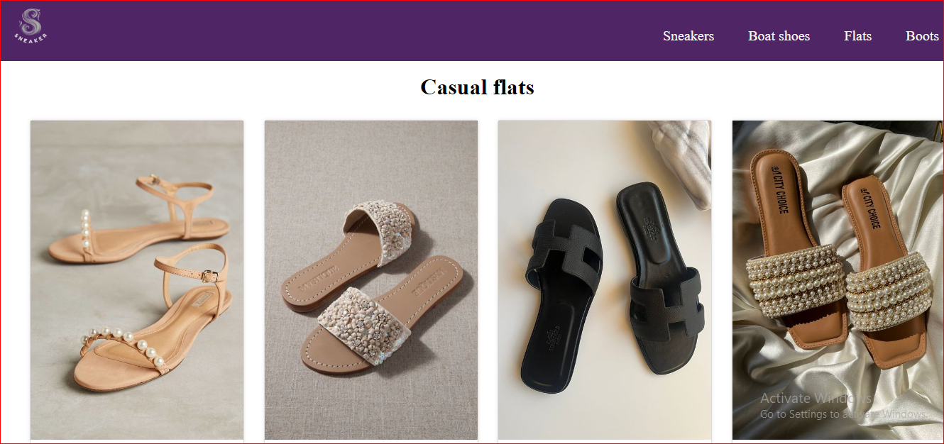

<body>: This is the main content area of the HTML document where visible content is placed.

<div class="image">: Contains the brand logo image.

<img src="logo/main logo.png" alt="" class="logo">: Displays the brand logo.

<nav class="menu">: Navigation menu for different product categories.

<a href="Boots.html">Boots</a>, <a href="flat.html">Flats</a>, <a href="boatshoe.html">Boat shoes</a>, <a href="sneaker.html">Sneakers</a>: Links to different product category pages.

<center>: Center-aligned content container.

<h1>Casual flats</h1>: Heading indicating the category of flats.

<div class="main">: Division containing the main content area.

<div class="card">: Container for individual flat cards.

<img src="flat/f1.jpg" alt="No Image Found">: Image of the flat.

<div class="container">: Container for flat details.

<h4><b>Women Classy</b></h4>: Title of the flat.

<p>Women</p>: Gender of the flat.

<p>Rs. 5,000</p>: Price of the flat.

<button>Buy Now</button>: Button to purchase the flat.

<div class="foot">: Footer section.

Footer content indicating copyright information.

1. Boat shoe page

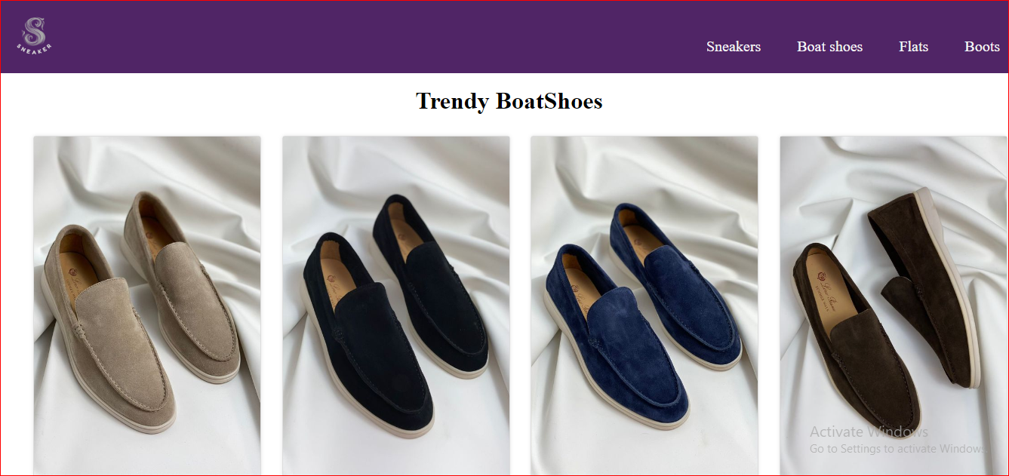

<body>: This is the main content area of the HTML document where visible content is placed.

<div class="image">: Contains the brand logo image.

<img src="logo/main logo.png" alt="" class="logo">: Displays the brand logo.

<nav class="menu">: Navigation menu for different product categories.

<a href="Boots.html">Boots</a>, <a href="flat.html">Flats</a>, <a href="boatshoe.html">Boat shoes</a>, <a href="sneaker.html">Sneakers</a>: Links to different product category pages.

<center>: Center-aligned content container.

<h1>Trendy BoatShoes</h1>: Heading indicating the category of boat shoes.

<div class="main">: Division containing the main content area.

<div class="card">: Container for individual boat shoe cards.

<img src="boat/b1.jpg" alt="No Image Found">: Image of the boat shoe.

<div class="container">: Container for boat shoe details.

<h4><b>Camel Boot</b></h4>: Title of the boat shoe.

<p>Unisex</p>: Gender specification of the boat shoe.

<p>Rs. 55,000</p>: Price of the boat shoe.

<button>Buy Now</button>: Button to purchase the boat shoe.

<div class="foot">: Footer section.

Footer content indicating copyright information.

1. Boots page

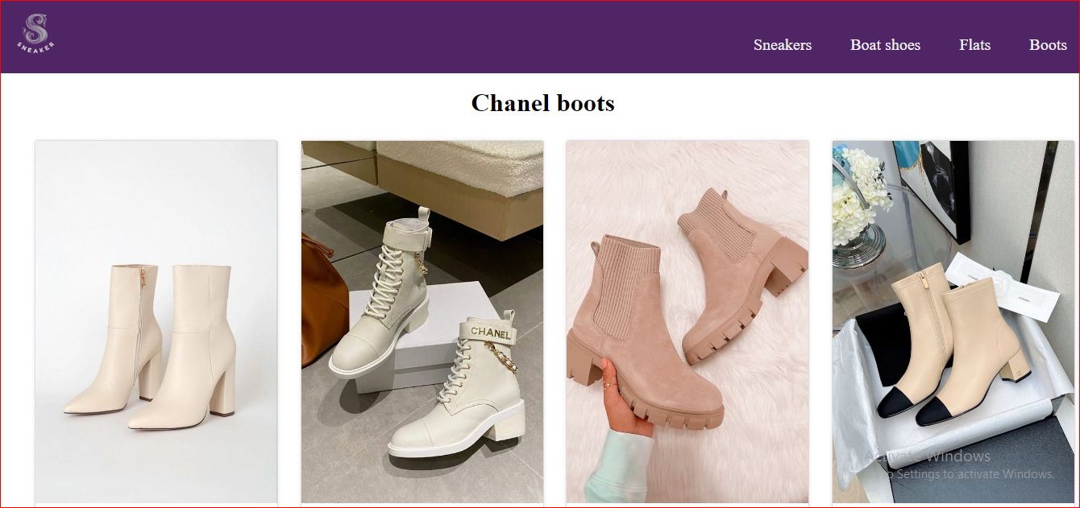

Document Type Declaration: <!DOCTYPE html> declares the document type and version of HTML being used.

HTML Element: <html lang="en"> marks the beginning of the HTML document, specifying the language as English.

Head Section: Contains metadata and links to external resources.

Character Encoding: <meta charset="UTF-8"> specifies the character encoding of the document as UTF-8.

Viewport Configuration: <meta name="viewport" content="width=device-width, initial-scale=1.0"> sets the viewport width to the device width and initial zoom level to 1.0 for better responsiveness.

External Stylesheet: <link rel="stylesheet" href="style.css"> links an external CSS file named "style.css" to apply styles to the HTML document.

Title: <title>SNEAKERS</title> sets the title of the HTML document to "SNEAKERS".

Body Section: Contains the visible content of the webpage.

Header: Contains the brand logo and navigation menu.

Brand Logo: <img src="logo/main logo.png" alt="" class="logo"> displays the brand logo.

Navigation Menu: <nav class="menu"> provides links to different product categories.

Main Content Area: Contains a collection of Chanel boots.

Heading: <h1>Chanel boots</h1> displays the heading for the collection.

Card Grid: <div class="main"> contains individual boot cards.

Boot Card: Each boot is represented by a card (<div class="card">) containing an image, boot details, and a "Buy Now" button.

Footer: Contains copyright information.

<div class="foot"> displays the copyright notice.

Closing Tags: </body> and </html> mark the end of the document's body and HTML respectively.